1.Question 1

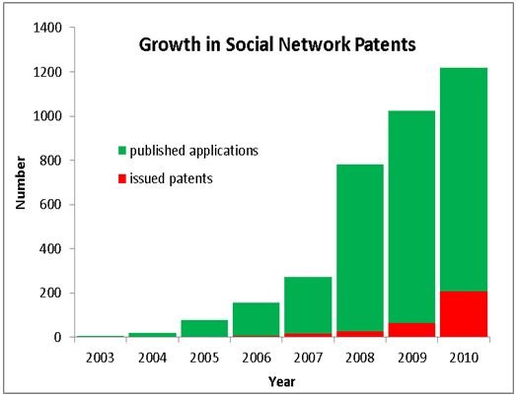

(source: https://en.wikipedia.org/wiki/File:Soc-net-paten-growth-chart.png)

Is the graph above an example of information or knowledge?

*Check one option.*



Information

2.Question 2

An episode of the TV fantasy drama series *Dragon's Play.*

Is this part of the cultural record or the scholarly record?

*Check one option.*



Cultural record

3.Question 3

Is a review of the book *The Politics of Free Markets* in the academic journal *Social Forces* an example of a primary source, a secondary source, or a tertiary source?



Secondary source

1.Question 1

Why can’t we rely just on textbooks as information sources at university?



Because they don’t provide deep knowledge of a subject



Because they present an unproblematic view of a field and don’t always present current debates in the field.

2.Question 2

Academic journal articles allow us to enter the discussions that define our academic field. However, what is a DISADVANTAGE of academic journal articles?



They are difficult to read because of the expert vocabulary used.

3.Question 3

What is the usual structure of a scientific journal article?

*Check one option.*



Abstract, Introduction, Methodology, Results, Discussion, Conclusion, References

1.Question 1

You are doing an assignment on media representations of women in business. Where would be a good place to begin your search?



Google



library aggregated search



YouTube

2.Question 2

Which of the following places will give information sources with greater quality, but with a more limited range of sources?



academic journal database



library website aggregated search

3.Question 3

According to Pat, how can you search sites such as academic databases more efficiently to get the information you want?

*Check 2 options.*



Boolean searching



Use key words from assignment.

1.Question 1

Consider the following question.

*“You have zero privacy anyway. Get over it” (Scott McNealey, 1999). What is privacy? How have changes in technology made privacy an issue for citizens and governments?*

The first step in developing a search strategy is to break the question down into sub-topics. Choose the best set of sub-topics for this question.

*Choose one option.*



Definition of privacy, technology privacy issues for citizens, technology privacy issues for governments

2.Question 2

Consider the following question.

*“You have zero privacy anyway. Get over it” (Scott McNealey, 1999). What is privacy? How have changes in technology made privacy an issue for citizens and governments?*

Another important step in developing a search strategy is to develop a set of search terms using synonyms of key words in the question. Choose the best set of synonyms of key terms from the groups below.



surveillance, computers, civilians, subjects, state, politics

**1 / 1 point**

3.Question 3

Consider the following question.

*“You have zero privacy anyway. Get over it” (Scott McNealey, 1999). What is privacy? How have changes in technology made privacy an issue for citizens and governments?*

A student has run the following search term while researching the question:

"privacy OR citizens OR government OR technology OR politics"

It has returned too many results, many of which are irrelevant. Why?

*Choose one option.*



The search is too wide because using OR as a search term widens the search.

4.Question 4

Consider the following question.

*“You have zero privacy anyway. Get over it” (Scott McNealey, 1999). What is privacy? How have changes in technology made privacy an issue for citizens and governments?*

A student wants to research the effects of technology on privacy for citizens. What is the best combination of search terms below?



privacy AND technology AND (civilians OR citizens OR subjects)